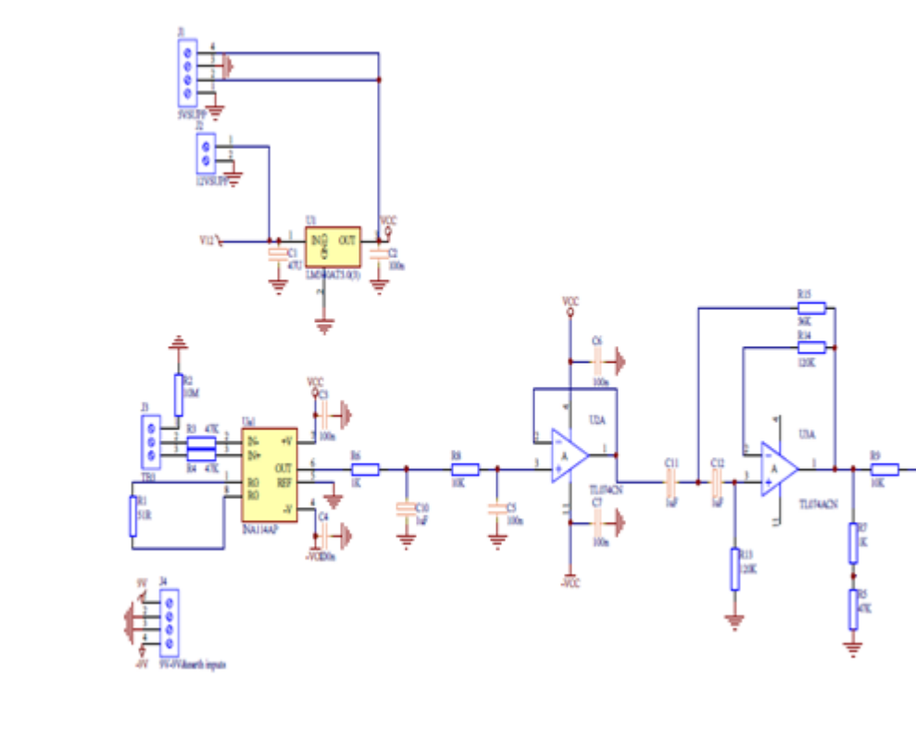

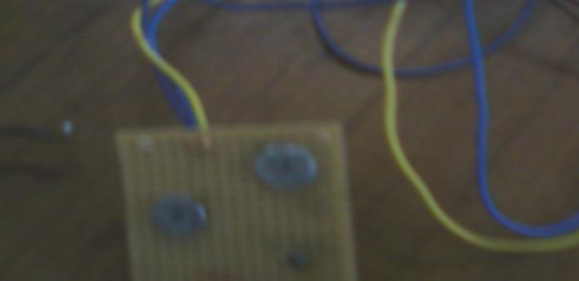

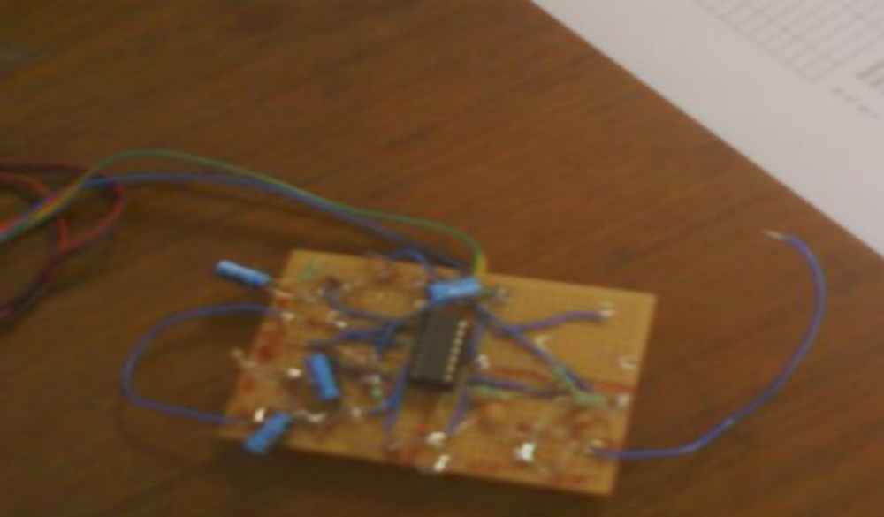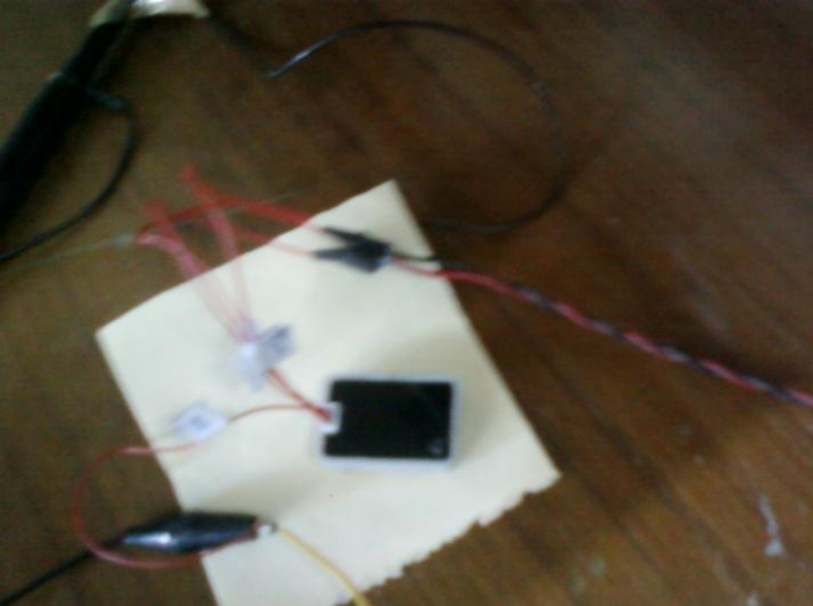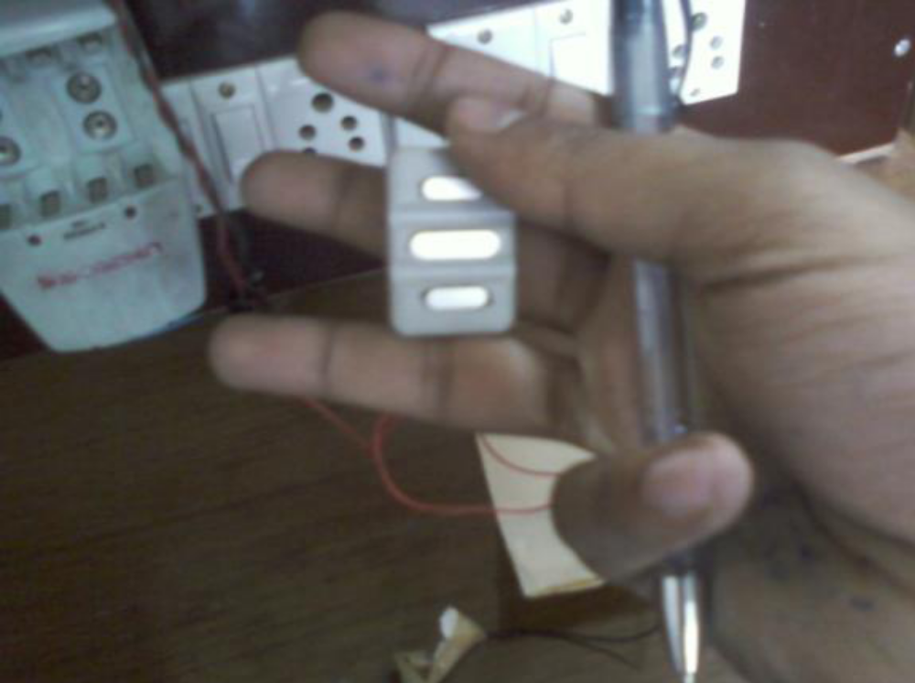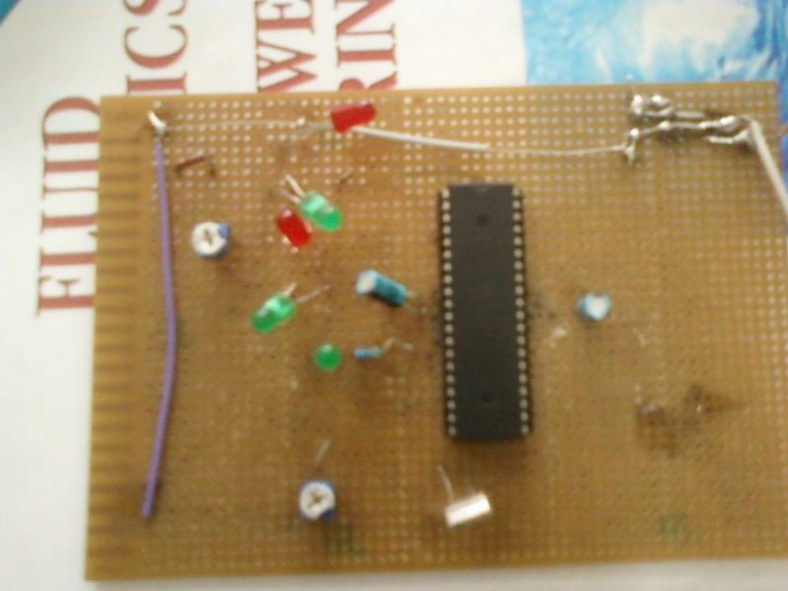duration = 1 % How many seconds of acquisition per plot refresh?
Fs = 5600 % Acquisition sample rate in Hz (try 8000)%% sound card frequency set to minimum 5600
%%% Initialization & configuration of sound card
AI = analoginput('winsound'); %%can be change three or four modes search
addchannel(AI, 1:2); %%IN ADDCHANNEL I HAVE ADDED ALSO CHANNEL 2
%%%ActualRate = setverify(ai,'SampleRate',Fs); %%NEW COMMAND BY
set (AI, 'SampleRate', Fs);
Set(AI, 'SamplesPerTrigger', duration*Fs);
%%% Loop to get data and display it
% this "try" helps the program end
% properly when "ctr+c" is hit
try
count = 0; % count how many time the while was executed
while 1
% increment loop counter
count = count +1;
% calculate elapsed time 32
ET = duration * count;
start(AI); % This #triggers# the input automatically as the trigger type is immidiate.
data = getdata(AI); % collects the data
pause(0.2)
figure(1010),
subplot(2,1,1)
plot(1:Fs,data)
%%%FOR RECORDING AND PLAYING
%%%signal =wavrecord(2*Fs); %sin(2*pi*0.055*(0:1000-1)');
%%% wavplay(signal);
%%% FIR FILTER CODE HERE COEFFECIENTS SHOULD BE EQUAL TO STATES
start(AI); % This #triggers# the input automatically as the trigger type is immidiate.
data = getdata(AI); % collects the data
figure(1010),
subplot(2,1,2)
plot(1:Fs,data)
% Results: udate a FFT magnitude plot
% xfft = abs(fft(data));
% mag = 20*log10(xfft); % Convert to dB
% mag = mag(1:end/2); % duscard the redundant half
% figure(1010), plot([1:length(mag)]./duration,mag)
% title(['FFT Magnitude ; Seconds Elapsed = ' num2str(ET) ])
%xlabel('Hz'), ylabel('dB'), grid on, axis([0 400 -60 60])
end
catch
disp('--> coninuous loop was manually interrupted')
end %%% Termination
disp('--> Deleting Analog Input Object')
stop(AI)
delete(AI) 